CLup

# Customer Line-up

1. **INTRODUCTION**
   1. *PURPOSE*  
      The purpose of this document is to build a more concrete foundation of what the system-to-be will be. It will also define the general behaviour and specific limitations of the system. This document is primarily addressed to the programmers and mostly includes technical language.
   2. *SCOPE*

The scope of the design document is to define the system’s behaviour in general cases and some critical scenarios, and to design the architecture of the system-to-be so as to provide a time-efficient, logical allocation of the components and the interaction between these components.

The document is not only limited to the architecture and behaviour of the components, but it also extends in part to the implementation and testing plan, where one possible course of action is explained, user interface design of user applications and requirements traceability relating to the Requirements and Specifications Document (RASD).

* 1. *DEFINITIONS, ACRONYMS, ABBREVIATIONS*
  2. *REVISION HISTORY*
  3. *REFERENCE DOCUMENTS*
  4. *DOCUMENT STRUCTURE*

1. **ARCHITECTURAL DESIGN**
   1. *Overview: high-level components and their interaction*

The architecture of the application is structured according to three logic layers:

* *Presentation Layer (P)* manages the presentation logic, namely the interaction with the user. It comprises a GUI (Graphic User Interface) that makes the application’s functionalities more understandable to the user.
* *Business Logic* or *Application Layer* (*A*) handles all the functions to provide to the user and manages the exchange of information between the user interface and the data source.
* *Data Access Layer* (*D*) provides access to the stored data. The implementation of the access logic should be both easy and structurally robust to guarantee a correct abstraction from the specific database and provide a model easy to use.

In order to guarantee as much flexibility and scalability as possible, the system is based on a 4-tier architecture (Client, Web Server, Application Server, Database Server) with a thin client. Since the application should be easy to use and executable in several different devices, the use of a thin client prevents a heavy computation load client side, carrying out all the heavy operation at server side. As represented in figure 2.1 the user, through a smartphone or a tablet, and the physical dispenser can directly communicate with the application server, while the store manager can access the functionalities devoted to him through a web application communicating with the web server. The use of a web server for the store manager’s functionalities is based on the fact that, in general, the web apps are quicker and easier to build, maintain and update and less expensive than the mobile apps, even if slower. The application server communicates with the data server to store the needed information. A more detailed description of the architectural design is given in the next section.

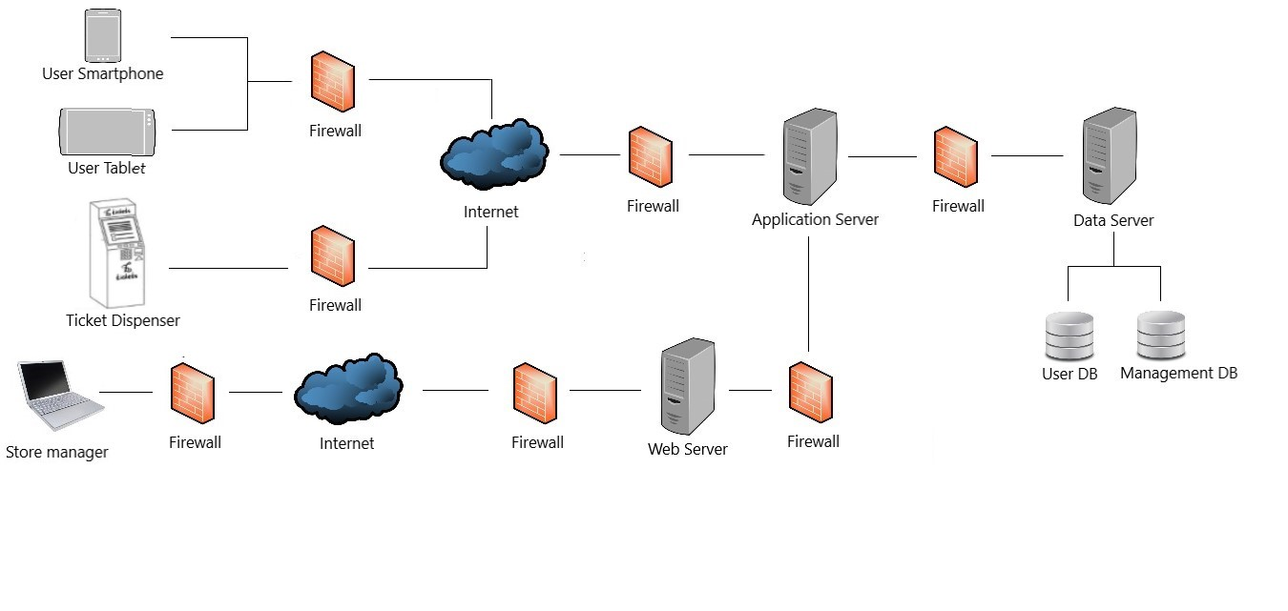

Figure 2.1 – high level architecture

* 1. Diagram

     Description automatically generated*Component view*

The image above shows the internal architecture of the Application Server and all the interfaces that are provided to the outside world, and all interfaces required.

Starting from what are conceptually two mediators, the system will contain two components called:

* *Map Mediator Module*   
  This component’s job is to communicate with the external API, by modifying the API’s information so that it can be comprehensible by the Application server, and adapting the requests to the API’s protocol, required by other modules of the server. It provides information regarding the local map with all the relevant stores in the map as well as an estimation of the time it takes to reach one store from a certain location.
* *Turnstile manager*  
  The turnstile manager, as opposed to the previous component, provides an interface for the turnstiles so that they can be opened or closed through the scans of the right QR codes.

For the authentication of an account, be it user or store manager, the following component will be of help:

* *Account manager*  
  This is the component which is responsible for the authentication of any user that wants to log in or ***register***, so it saves all the relevant information about that account and furthermore, provides to all users the possibility to fetch all upcoming tickets that they have an appointment for.

Once a user is logged in the system, this must provide functionalities to the user that allow him to book visits, get tickets, be reminded of upcoming visits and be suggested different stores in case the requested ones are full. The following components allow users to:

* *Reservation manager*  
  It provides the interfaces that allow booking of tickets and visits. It communicates with different components to provide the functionalities required by tickets and visits requests i.e., check the relevant, available timeslots, gets the info that will allow the presentation layer to build map of the available shops around the user’s current location, handle visits additional info…(See interface diagram for a more detailed list)
* *Notification manager*  
  This component has the job of handling notifications of two types:   
  -reminding users when it is time to leave their current location so to reach in time their destination; to do this, the component interfaces with the maps provider, getting info on ETA.   
  -provide suggestions of relevant available stores and timeslots when the requested one is full or the user is inactive.

Instead, functionalities related to the store managers are provided by the following component:

* *Market Manager*  
  Issues, through its interfaces, the functionalities of controlling how many customers can enter in the store, how many people are inside of said store and the statistics regarding all entrances within a certain period.

The components which connect everything together and provide the logic of the dispensing of tickets are the following:

* *Queue Manager*This is the most critical and important component of the system, as it defines and handles timeslots and the queue. Through the timeslot manager subcomponent, timeslots are searched to see or update their availability on new tickets requests. It also generates QRCodes for new tickets and visits, assigning them to available timeslots, and checks QRCodes on scan, so to correctly update the state of the queue in that timeslot.  
  The other components is a timeslot optimizer, that is a periodic activated component, which handles aspects of the optimization of timeslots, as the maximum number of people that can enter considering info about user visits that declared their shopping list or departments they will visit; another possible optimization is the duration of timeslots, performed once in a greater period of time w.r.t. to the previous one, that could optimize the duration of timeslots based on the average shopping duration.
* *Location Module*  
  It provides interfaces that allow the search of the closest stores in a range around a given location, filtering on the stores that are registered and use CLup; it also provides the ETA services, needed by other components to have an estimation of the user distance (quantified in time) from the given location. To provide these services, it interfaces with the Mediator, that will then process and forward requests to the external API.
  1. *Deployment view*   
       
     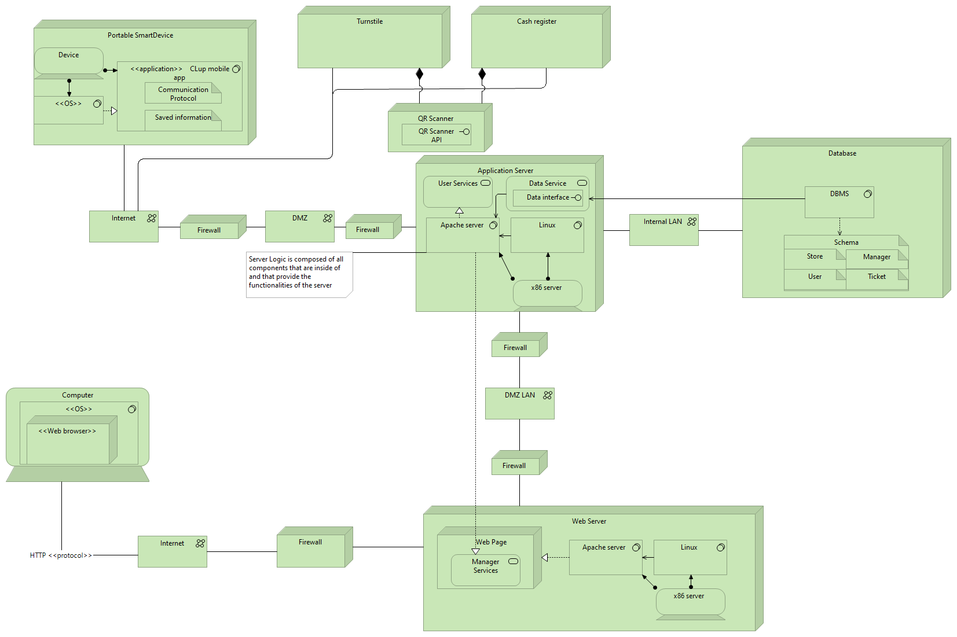  
     Some important aspects to highlight are the following:
* With Portable SmartDevice we mean any mobile device such as tablets and smartphones. With OS we intend either IOS or Android.   
  In computer, any OS and Web browser can communicate with the web server as long as the HTTP protocol is being used.
* The CLup mobile app will store information in the client side such as upcoming tickets data, for faster data retrieval and user information for identification. It furthermore uses a specific communication protocol that the programmers might see fit.
* The installation of the CLup mobile app is done through the mobile phone’s application store and is not been shown in the deployment view.
* The application server is connected to the database through an internal LAN with no firewalls, for increased connection speed.
* Turnstiles and cash registers need to forward information regarding QR codes through the internet.
  1. *Runtime view*: You can use sequence diagrams to describe the way components interact to accomplish specific tasks typically related to your use cases
  2. *Component interfaces*
  3. *Selected architectural styles and patterns*: Please explain which styles/patterns you used, why, and how
  4. *Other design decisions*

1. USER INTERFACE DESIGN:

Here we include some draft mockups about how the mobile applications and the web application should look like. As they are drafts, these are not to be intended as strictly constraining designs: backgrounds, styles, text formatting and page structure are simplified and rough, as we want just to give an idea of the general schema of the pages.

1. Mobile App Mockups  
     
   Map

   Description automatically generatedGraphical user interface, application

   Description automatically generatedAs already mentioned in RASD, the mobile app must have simple and intuitive interfaces, as to be easily usable by users that may not be practical with technology (as may be elderly people).

Shop selection

Home page of the app

The app will allow user to define first either the shop or the date and time, in the case of “Book a visit”, it is not shown in this demo because it is similar and irrelevant.

*Mockups are taken from an interactive graphic demo with graphic-driving purposes only, linked in the “reference documents” paragraph.

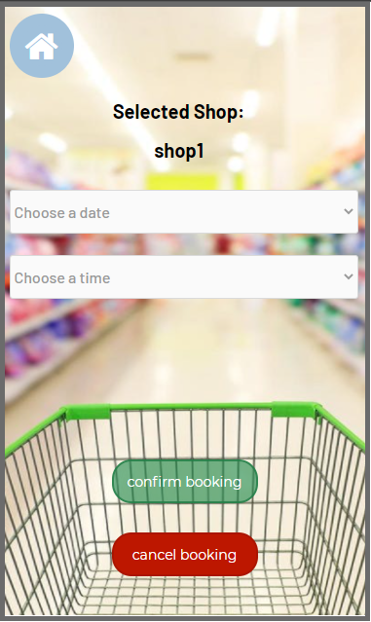In the case of “book a visit”, after the shop selection, the app will allow registered users to select their shopping list:

book a visit as registered user

book a visit as Guest

Ticket Confirmation

Ticket proposal

1. Shop Manager Web App mockups

The web app for managers will allow only to login with an authorized account. For security purposes, such account cannot be registered directly through the Web App, but it has to be set up by CLup System staff through certified communication with the market/market chain.  
The web app must allow managers to trace entrances, to see the queue state of any timeslot, and to see statistics as average time of shopping and the average influx in a given period.

In the real app other statistics may be implemented, as the most declared shopping items or departments (given by user that specified these elements in their visits). Graphics in the real app may be interactive, allowing more interactivity, usability and utility.

Web App homepage

The “Manage Shop” page is not shown here, it simply allows managers to add or update logistics info for the shop, as product positions or departments. It just lists departments and their items.

Web App Statistics page

The page shown upon clicking the “See” button next to the declared shopping list is not shown here, since it is unnecessary as it simply shows the list of declared items.   
As shown in the image, physical users have no Id, but they still are tracked and considered correctly in the queue state.

Web App Queue State

1. REQUIREMENTS TRACEABILITY: Explain how the requirements you have defined in the RASD map to the design elements that you have defined in this document.
2. IMPLEMENTATION, INTEGRATION AND TEST PLAN: Identify here the order in which you plan to implement the subcomponents of your system and the order in which you plan to integrate such subcomponents and test the integration.
3. EFFORT SPENT: In this section you will include information about the number of hours each group member has worked for this document.
4. REFERENCES